LAB OUTPUT

1.CREATE DATABASE & TABLE
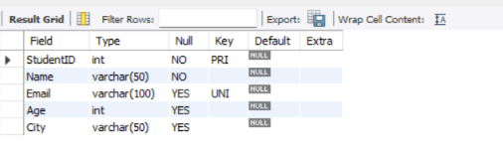

2.NSERT RECIORDS
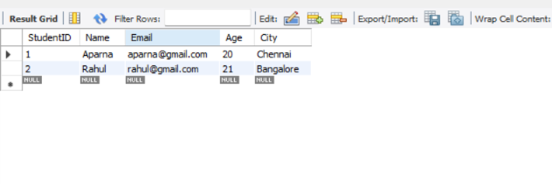
3.UPDATE & DELETE
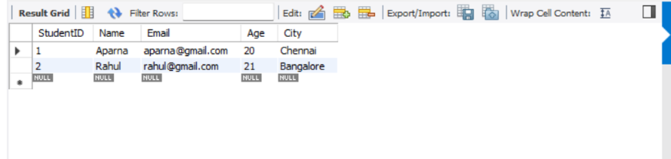
4.SIMPLE SELECT QURIES
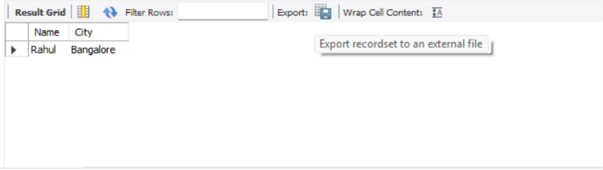

5.SORTING & FILTERING

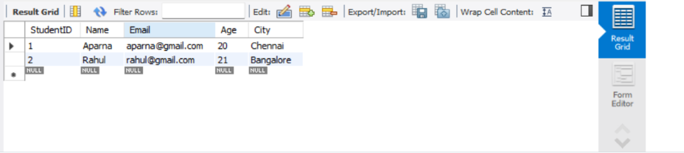
6.AGGREGATE FUNCTIONS
Total Number
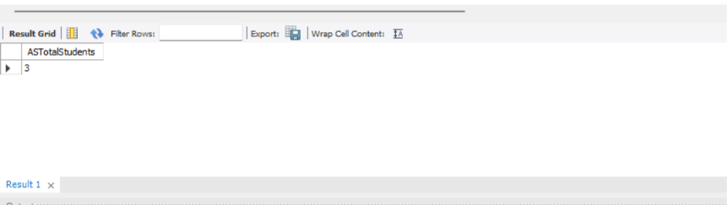
Sum Of Age
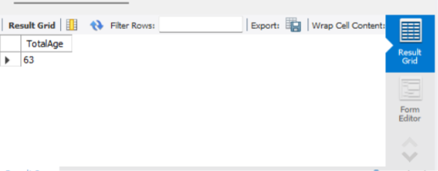
Avg Age
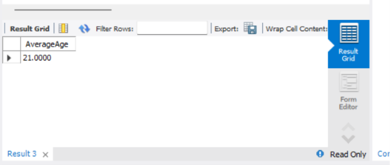
Mini Age
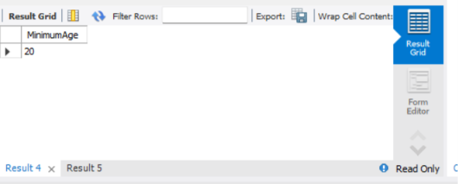
Max Age
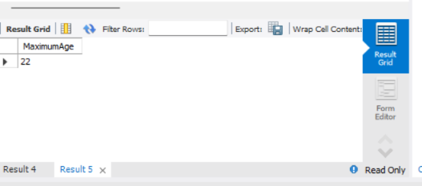
7.GROUP BY & HAVING
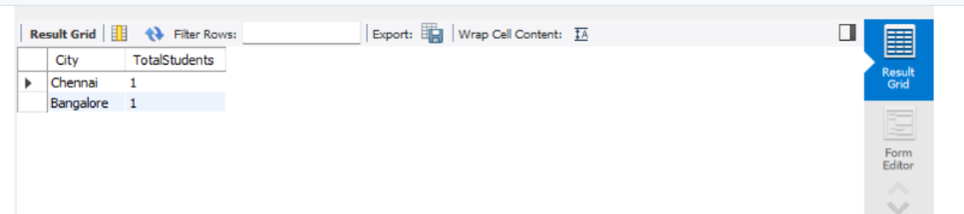
8.JOIN
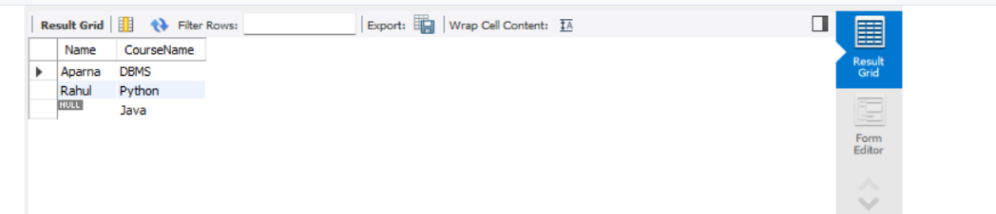
9.SUBQURIES
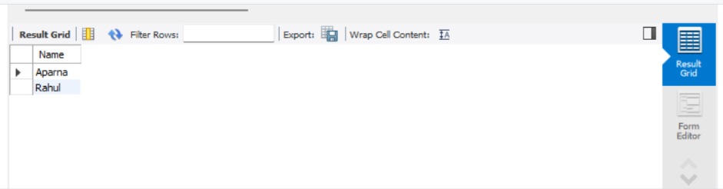
10.VIEWS
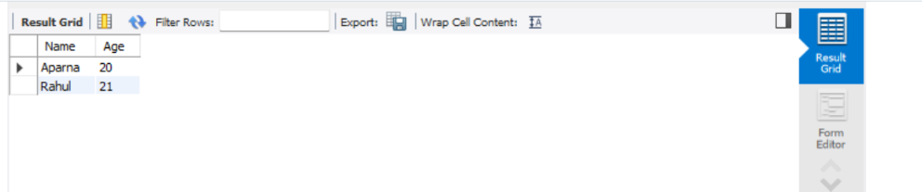
11.CONSTRAINTS
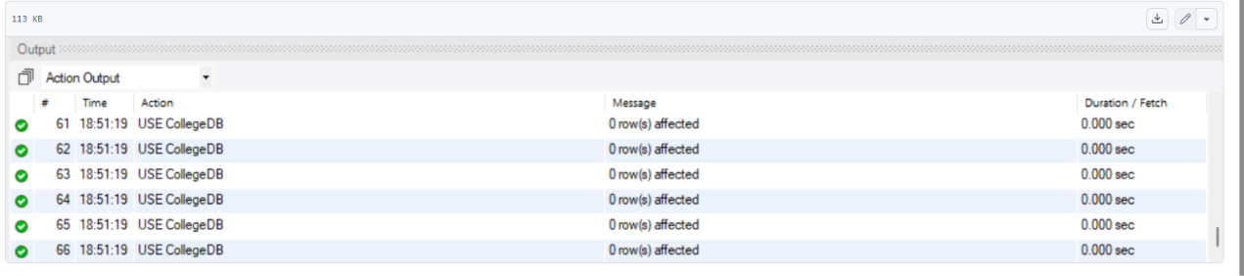
12.INDEXING
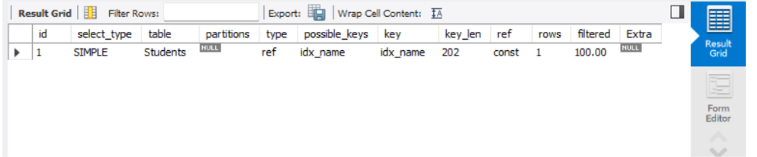
13.STRING & DATE FUNCTION
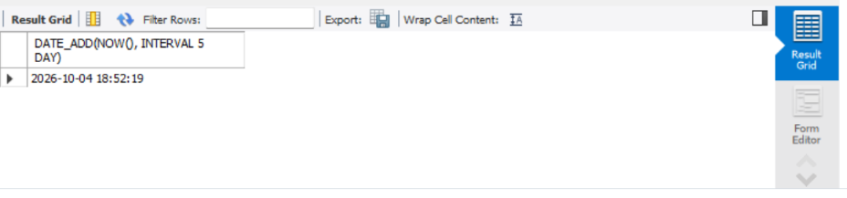
14.SET OPERATORS
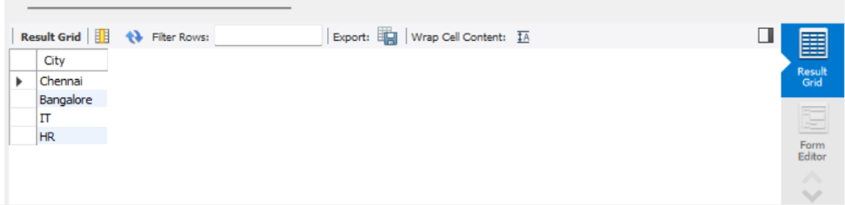
15.TRANSACTIONS
